House Ownership Rate & Fertility Rate

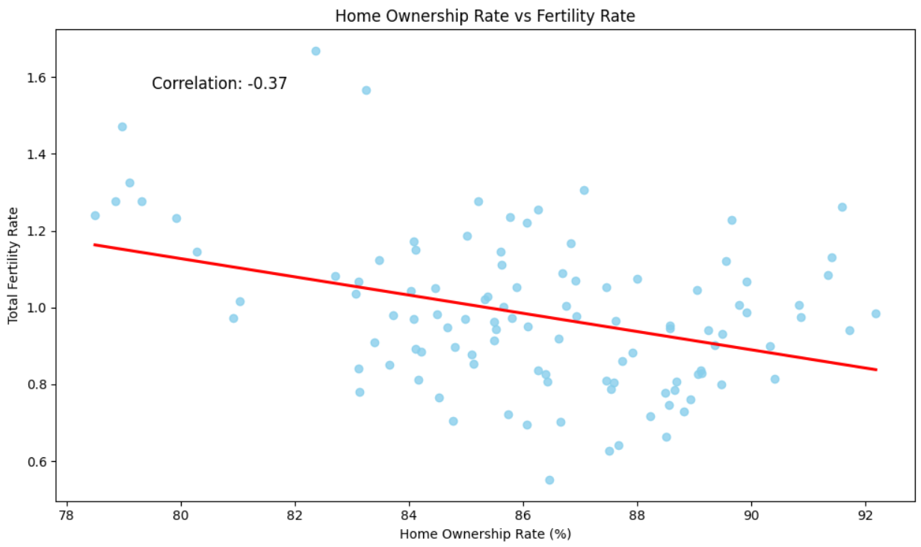

### What does ****-0.37**** mean in your case?

**Direction**: Negative → as home ownership increases, fertility tends to decrease.

**Strength**: Moderate → not weak (like -0.1), but not strong (like -0.7 either).

**Interpretation**: Housing may be **one of several contributing factors**, but not the sole or dominant one affecting fertility.

### Final Answer Summary for Question 1:

Based on the merged data and scatter plot analysis, there is a **moderate negative correlation** between home ownership rate and fertility rate across South Korean provinces (**correlation coefficient = -0.37**). The downward trend observed in the scatter plot suggests that higher rates of home ownership do not correspond to increased fertility. In fact, provinces with higher home ownership tend to have slightly lower fertility rates. This implies that housing availability alone is not a strong driver of fertility decisions, and broader social or economic factors are likely influencing these trends.

House Ownership Rate & Crude Marriage Rate

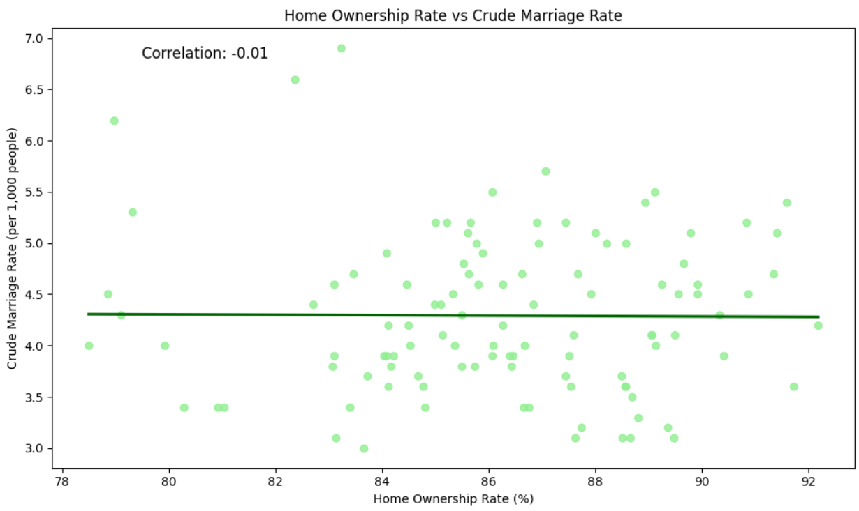

A flat regression line,

A **correlation coefficient of -0.01**, which is **close to 0**.

**What this means:**  
There is **no statistically significant linear relationship** between the **home ownership rate** and the **crude marriage rate**. In simpler terms:

Higher or lower rates of home ownership do **not appear** to impact how often people get married (as measured by crude marriage rate).

***Answer:***

To summarize, **home ownership rate seems to be more related to fertility patterns than to marriage rates**, and this is supported both visually and statistically. Therefore, **home ownership may play a more influential role in fertility behavior than in marriage trends**.

Growth Price Index & Fertility Rate

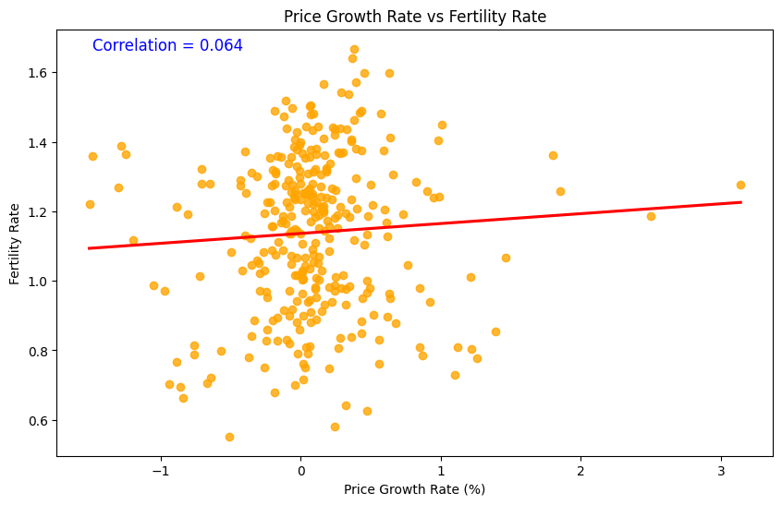

· **Correlation:** 0.064

· **Interpretation:** The correlation between house price growth rate and fertility rate is very weak and positive. The data points are widely scattered, and the trend line is nearly flat.

· **Conclusion:** There is no meaningful relationship between housing price increases and fertility rate. Changes in housing prices do not seem to significantly influence fertility rates across provinces and years. Other factors likely play a more substantial role in fertility decisions.

Growth Price Index & Crude Marriage Rate

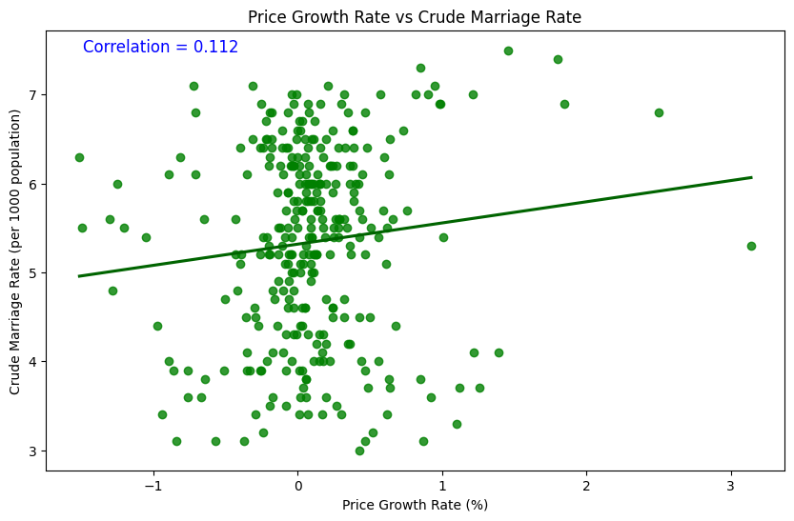

· **Correlation:** 0.112

· **Interpretation:** The correlation is still weak, but slightly stronger than the fertility rate plot. There is a small positive trend, suggesting that as price growth increases, marriage rates might increase a little, but the association is minimal.

· **Conclusion:** There is a very small positive association between housing price growth and marriage rates. However, this relationship is weak and not strong enough to conclude that rising housing prices directly impact marriage rates. Again, marriage rates are likely influenced by a variety of socio-economic and cultural factors beyond house price growth.